Polynomial and Rational Functions Name _________________________
A2RCC U8D3 Homework
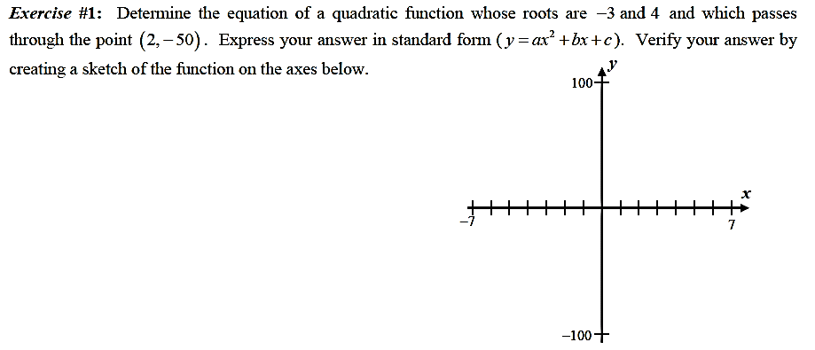

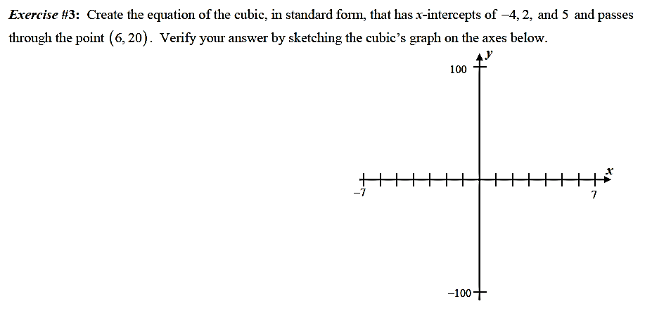
Exercise #2:

Review:
- Circle the polynomial functions. Put them in standard form and state a) the degree, b) # of terms, c) leading term, d) leading coefficient, e) end behavior, and e) constant term.
A) $y = 3x^{2} + 5$ B) $y = 4x^{2}- 7\sqrt{x^{9}} + 10$ C) $y = -5x^{7} – 2$

D) $y = -7x^{4} – 8x+ \sqrt{6}$ E) $y = 3.1 – 8x^{2} + 5x^{5} – 12.3x^{4}$ F) $y = -x^{-2} + 5x$

- Determine whether each of the following functions is a power function. If it is, identify $a$ and $b$. If it isn't, then tell why.
A) $y = 5x^{2} + 3$ B) $2y = 6x^{2}$ C) $y = * 5x$

D) $y = 3{(x+2)}^{2}$ E) $y = 3(x-2)(x+2) + 12$ F) $y = 3.2$

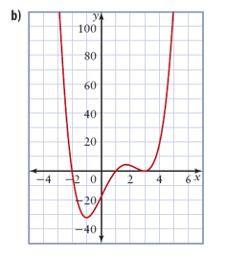
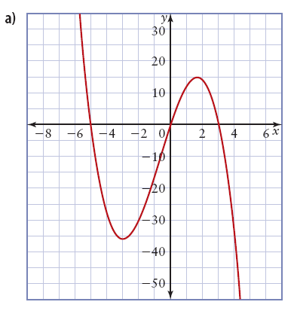
- For each graph of a polynomial function, determine a) whether the exponent of the controlling term is odd or even, b) the sign of the leading coefficient, c) the x-intercepts, and d) the factors of the function

- Solve the following polynomial functions algebraically.
- $2x^{3}+24x^{2}-56x=0$ b) $3x^{4}-2x^{2}-5=0$

